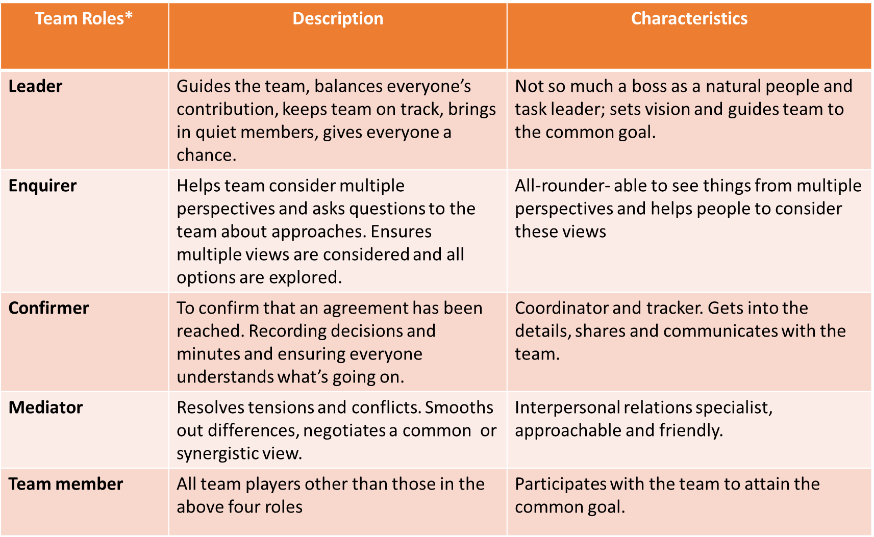
Functions that need to be carried out so that the team runs smoothly (McCulloch & Reid, 2012)
MY TEAM MEMBERS:
Team Member Names

What I like most about teamwork
What I dislike most about teamwork
What makes me a good team player (i.e. strengths such as skills, knowledge)
What makes me a bad team player (e.g.poor time management)
The mark I hope to achieve for the case study.

Source: http://www.iml.uts.edu.au/learn-teach/groupwork/resources/getting.pdf (Accessed and Adapted: 19 July 2016)

